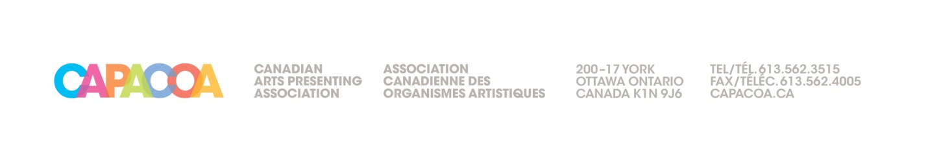
CAPACOA
(the “Corporation”)
PROXY
FOR ANNUAL GENERAL AND SPECIAL MEETING OF MEMBERS
TO BE HELD ON OCTOBER 23, 2018
The undersigned Member of the Corporation hereby appoints ___________________________
or, failing him/her, the chair of the meeting, as proxy of the undersigned to represent the undersigned at the Annual General Meeting of Members to be held online via Adobe Connect on the 23rd day of October 2018 at 12:00 noon (EST) or at any adjournment or adjournments of said meeting and at such meeting to vote for the undersigned upon any and all matters which may come before the meeting, and to do any and all acts and things which the undersigned might or could do if personally present. The undersigned hereby undertakes to ratify and confirm all that the said attorney and proxy of the undersigned may do or cause to be done by virtue hereof.
IN WITNESS WHEREOF the undersigned has executed this Proxy by its authorized officer, the
______ day of ______, 2018.
Name of Member
(please print)
(Signature of Member)
Please EMAIL TO Mélanie Bureau AT melanie.bureau@capacoa.ca

